**Renewable Energy Partners Project Spotlight**

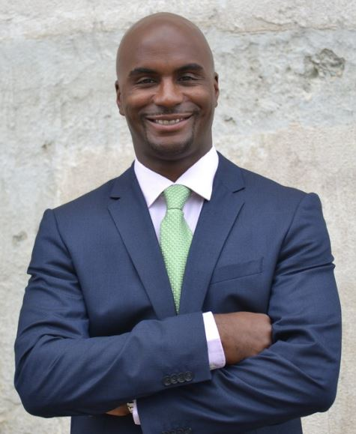

**Jamez Staples**

Renewable Energy Partners, Inc. is a black-owned Minnesota-based company that was founded by Jamez Staples in 2014 to provide full-service energy solutions while empowering the community through multi-purpose training.

Their training for certifications and degree programs take work-ready candidates from entry-level jobs to higher-skill careers with energy utilities and energy-related businesses.

**Renewable Energy Partners North MSP | $531,940 Equity Commitment**

Two roof-mounted community solar gardens located in Minneapolis, MN.

* The North Project (366kWDC) system on North Community High School located on the north side of Minneapolis. The project is a partnership with the City of Minneapolis and Minneapolis Public Schools and the residential solar garden subscriptions will be reserved for low-income households in the neighborhood.
* The Emerge Project (173kWDC) on Emerge Second Chance Recycling Facility in Northeast Minneapolis. The facility provides employment for over 100 people overcoming barriers to re-entering the workforce. This project is a partnership with Minneapolis Climate Action, a non-profit advocate for solar energy that will also serve as the community solar garden operator for both Projects.

